LIS
SR | USER Requirements | GPT Results | VeriGen Results
 | The system supports (but does not require) streamlined staff login methods. | 1 The system shall provide users with the ability to log in using streamlined login methods.  2 The system shall be able to support traditional login methods in addition to streamlined login methods. | 1. The system shall be able to support but not require streamlined staff login methods.
 | Administrators can create reliable report templates that are available to staff, and can be run as is or modified to the staff person's particular needs. | 3 The system shall provide administrators with the ability to create report templates.  4 The system shall provide administrators with the ability to define which report templates are available to staff.  5 The system shall provide staff with the ability to run report templates as provided by administrators.  6 The system shall provide staff with the ability to modify report templates to suit individual needs, subject to administrator-defined restrictions. | - The system shall provide administrators with the ability to create reliable report templates that available to staff ,.  3. The system shall be able to run particular persons needs.
 | The administrator can limit the filters and display fields that can be altered to certify a dependable output. | 7 The system shall provide administrators with the ability to limit which filters in a report template can be altered by staff.  8 The system shall provide administrators with the ability to limit which display fields in a report template can be altered by staff.  9 The system shall be able to enforce restrictions on filters and display fields to ensure dependable report output. | 4. The system shall provide administrator with the ability to limit the filters and display fields that altered to certify a dependable output.
 | System provides distinct, fine-grained permission levels limiting who can create and clone reports. | 10 The system shall provide the ability to define distinct permission levels for report creation.  11 The system shall provide the ability to define distinct permission levels for report cloning.  12 The system shall be able to restrict report creation functionality based on user permissions.  13 The system shall be able to restrict report cloning functionality based on user permissions. | 5. The system shall be able to provide distinct , finegrained permission levels limiting who create and clone reports.
 | All permissions be easy to administer. | 14 The system shall provide administrators with the ability to easily administer all report-related permissions. | 6. The system shall be able to be easy permissions administer.
 | System administrators can create shared folders to allow or disallow staff to run specific reports, and/or to run ad hoc reports on specific sets of data. | 15 The system shall provide administrators with the ability to create shared folders for reports.  16 The system shall provide administrators with the ability to allow or disallow staff to run specific reports within shared folders.  17 The system shall provide administrators with the ability to allow or disallow staff to run ad hoc reports on specific data sets. | 7. The system shall provide staff with the ability to create shared folders to allow or disallow to run specific reports , andor to run ad hoc reports on specific sets of data.
 | System provides a user-friendly interface for designing queries against all record types. | 18 The system shall provide a user-friendly interface for designing queries against all record types.  19 The system shall provide staff with the ability to select fields to query in the report designer. | 8. The system shall be able to provide a user friendly interface for designing queries against all record types.
 | Staff can select fields to query select values from picklist of possible values select regular expressions from drop-down menu, and use a full range of Boolean operators. | 20 The system shall provide staff with the ability to select values from a picklist of possible values when designing queries.  21 The system shall provide staff with the ability to select regular expressions from a drop-down menu when designing queries.  22 The system shall provide staff with the ability to use Boolean operators (AND, OR, NOT) in query design. | 9. The system shall provide staff with the ability to select fields to query select values from picklist of possible values select regular expressions from dropdown menu , and use a full range of boolean operators.
 | Administrators control staff access to tables and fields. | 23 The system shall provide administrators with the ability to control staff access to specific tables.  24 The system shall provide administrators with the ability to control staff access to specific fields. | 10. The system shall provide administrators with the ability to control staff access to tables and fields.
 | The system provides pre-defined reports for consumption by library boards or other consumers. | 25 The system shall provide pre-defined reports for consumption by external consumers such as library boards.  26 The system shall provide pre-defined reports for consumption by other external consumers as specified. | 11. The system shall be able to provide predefined reports for consumption by library boards or other consumers.
 | There will be reports providing basic statistics like those required by the Georgia Annual Report and Application for State Aid and activity reports that indicate traffic and volume of use that display statistics on check-outs, check-ins, holds placed, and holds filled. | 27 The system shall provide reports that include basic statistics required by the Georgia Annual Report.  28 The system shall provide reports that include statistics required by the Application for State Aid.  29 The system shall provide activity reports that display statistics on check-outs.  30 The system shall provide activity reports that display statistics on check-ins.  31 The system shall provide activity reports that display statistics on holds placed.  32 The system shall provide activity reports that display statistics on holds filled. | 12. The system shall provide report with the ability to indicate display holds placed holds filledThe system shall be able to able to support the reporting definitions as described in appendix a.
 | System must be able to support the reporting definitions as described in Appendix A. | 33 The system shall be able to support reporting definitions as described in Appendix A. | MISSING
 | System must be able to support the fine-grained reports requirements as described in Appendix B. | 34 The system shall be able to support fine-grained reporting requirements as described in Appendix B. | 13. System able to support the finegrained reports requirements as described in appendix b.
 | The system produces statistics that can be used to understand and predict patron behavior and use of materials. | 35 The system shall be able to produce statistics that can be used to understand patron behavior.  36 The system shall be able to produce statistics that can be used to predict patron use of materials. | 14. The system shall be able to produce statistics that used to understand and predict patron behavior and use of materials.
 | The system produces useful demographic statistics, including transactions by geographical regions, age ranges, etc. | 37 The system shall be able to produce demographic statistics, including transactions by geographical region.  38 The system shall be able to produce demographic statistics, including transactions by age range. | 15. The system shall be able to produce useful demographic statistics , including transactions by geographical regions , age ranges , etc.
 | The system provides an interface showing capacity of all branches (as defined in PINES-014). | 39 The system shall provide an interface displaying the capacity of all branches as defined in PINES-014. | 16. The system shall be able to provide an interface showing capacity of all branches as defined in pines014.
 | System ability to compare the percentage of total circulations, the percentage of the collection, and the percentage of total shelf space that genre/format comprises. | 40 The system shall be able to compare the percentage of total circulations for each genre or format.  41 The system shall be able to compare the percentage of the collection for each genre or format.  42 The system shall be able to compare the percentage of total shelf space for each genre or format. | 17. System ability to compare the percentage of total circulations , the percentage of the collection , and the percentage of total shelf space that genreformat comprises.
 | System ability to control inventory of uncatalogued material, such as paperback books and children's board books. | 43 The system shall provide the ability to control inventory of uncatalogued material, such as paperback books.  44 The system shall provide the ability to control inventory of uncatalogued material, such as children's board books. | 18. The system shall be able to control uncatalogued such ability inventory material , paperback books and childrens board books.
 | System provides a utility for transferring batches of items between branches, used for example to move books into a mobile library, an outreach program collection, or a "just in time" warehouse. | 45 The system shall provide a utility for transferring batches of items between branches.  46 The system shall be able to transfer batches of items to a mobile library.  47 The system shall be able to transfer batches of items to an outreach program collection.  48 The system shall be able to transfer batches of items to a "just in time" warehouse. | 19. The system shall be able to provide a utility for transferring batches of items between branches , used for example to move books in to a mobile library , an outreach program collection , or a just in time warehouse.
 | The system generates a list of items that have been in-transit for more than X days (X configurable), per branch and per system. | 49 The system shall generate a list of items that have been in-transit for more than X days, where X is configurable.  50 The system shall generate the in-transit items list per branch.  51 The system shall generate the in-transit items list per system. | 20. The system shall be able to generate a list of items that intransit for more than x days x configurable , per branch and per system.
 | The report would merge the transit to and transit from into one report for ease of front-line staff use. | 52. The system shall merge transit-to and transit-from data into a single report for in-transit items. | 21. The system shall provide report with the ability to merge the transit to and transit from in to one report for ease of frontline staff use.
 | The system provides a utility and reports for identifying item records to purge, based on customizable criteria. | 53 The system shall provide a utility for identifying item records to purge based on customizable criteria.  54 The system shall provide reports for identifying item records to purge based on customizable criteria. | 22. The system shall be able to provide a utility and reports for identifying item records to purge , based on customizable criteria.
 | The system has a report to assist in the conversion of items from one status to another. | 55 The system shall provide a report to assist in the conversion of items from one status to another. | 23. The system shall be able to have a report to assist in the conversion of items from one status to another.
 | The system provides a last copy report that would single out a library system's last copies, to assist catalogers who need to edit WorldCat entries. | 56 The system shall provide a last copy report to identify a library system's last copies. | 24. The system shall be able to provide a last copy report that single out a library systems last copies , to assist catalogers who need to edit worldcat entries.
 | The system provides a quick effective method of deleting volume entries along with copy entries, as well as records with no items attached. | 57 The system shall provide a method for deleting volume entries along with associated copy entries.  58 The system shall provide a method for deleting records with no items attached. | 25. The system shall be able to provide a quick effective method of deleting volume entries along with copy entries , as well as records with no items attached.
 | System ability to count and track record deletions ( item records, patron records) per location and per system. | 59 The system shall be able to count record deletions (item records) per location.  60 The system shall be able to count record deletions (item records) per system.  61 The system shall be able to count record deletions (patron records) per location.  62 The system shall be able to count record deletions (patron records) per system. | 26. The system shall be able to count ability and track record deletions item records , patron records location and.
 | The system generates a list of patrons with no circulation or electronic activity in the last X days (X configurable). | 63 The system shall generate a list of patrons with no circulation or electronic activity in the last X days, where X is configurable. | 27. The system shall be able to generate a list of patrons with no circulation or electronic activity in the last x days x configurable.
 | The system counts all types of check-in individually and cumulatively book-drop, by terminal, by user or self-service. | 64 The system shall count all types of check-in individually and cumulatively by book-drop.  65 The system shall count all types of check-in individually and cumulatively by terminal. | 28. The system shall be able to count all types of checkin individually and cumulatively bookdrop , by terminal , by user or selfservice.
 | The system counts all types of check-out individually and cumulatively: staff check-out, self check-out, staff renewal, self checkout renewal, online renewal, OPAC renewal. | 66 The system shall count all types of check-in individually and cumulatively by user or self-service.  67 The system shall count all types of check-out individually and cumulatively for staff check-out.  68 The system shall count all types of check-out individually and cumulatively for self check-out.  69 The system shall count all types of check-out individually and cumulatively for staff renewal.  70 The system shall count all types of check-out individually and cumulatively for self check-out renewal.  71 The system shall count all types of check-out individually and cumulatively for online renewal.  72 The system shall count all types of check-out individually and cumulatively for OPAC renewal. | 29. The system shall be able to count all types of checkout individually and cumulatively staff checkout , self checkout , staff renewal , self checkout renewal , online renewal , opac renewal.
 | The system counts all hold requests, including how the hold was placed: at a staff desk, at a public computer inside the library, or remotely. | 73 The system shall count all hold requests, including those placed at a staff desk.  74 The system shall count all hold requests, including those placed at a public computer inside the library.  75 The system shall count all hold requests, including those placed remotely. | 30. The system shall be able to count all hold requests , including how the hold placed at a staff desk , at a public computer inside the library , or remotely.
 | The system can generate a report of transactions (holds placed, holds filled, and check-outs) per patron, per library, per selected group libraries, per system, per county. | 76 The system shall generate a report of transactions (holds placed, holds filled, check-outs) per patron.  77 The system shall generate a report of transactions (holds placed, holds filled, check-outs) per library.  78 The system shall generate a report of transactions (holds placed, holds filled, check-outs) per selected group of libraries.  79 The system shall generate a report of transactions (holds placed, holds filled, check-outs) per system.  80 The system shall generate a report of transactions (holds placed, holds filled, check-outs) per county. | 31. The system shall be able to generate a report of transactions holds placed , holds filled , and checkouts per patron , per library , per selected group libraries , per system , per county.
 | The system displays the number of check-outs and placed holds per patron. | 81 The system shall display the number of check-outs per patron.  82 The system shall display the number of placed holds per patron. | 32. The system shall be able to display the number of checkouts and placed holds per patron.
 | Staff can obtain value of all items with status of long overdue, or value of all DVDs in children's collection, or value of entire collection. | 83 The system shall generate a report of the value of items in the entire collection based on item record data.  84 The system shall generate a report of the value of items in a portion of the collection based on item record data.  85 The system shall provide staff with the ability to obtain the value of all items with a status of long overdue.  86 The system shall provide staff with the ability to obtain the value of all DVDs in the children's collection.  87 The system shall provide staff with the ability to obtain the value of the entire collection. | - The system shall be able to generate a report of the value of items based on data in item record in the entire collection or a portion.  34. The system shall provide staff with the ability to obtain value of all items with status of long overdue , or value of all dvds in childrens collection , or value of entire collection.
 | All reports and data archiving must comply with standard accounting practice and state, county, and municipal auditing requirements. | 88 The system shall ensure that all reports and data archiving comply with standard accounting practices.  89 The system shall ensure that all reports and data archiving comply with state auditing requirements.  90 The system shall ensure that all reports and data archiving comply with county auditing requirements.  91 The system shall ensure that all reports and data archiving comply with municipal auditing requirements. | 35. The system shall be able to comply archiving standard municipal reports and data accounting practice and state , county , and auditing requirements.
 | System tracks fines waived and payments made per library. | 92 The system shall track fines waived per library.  93 The system shall track payments made per library. | 36. The system shall be able to track fines waived and payments made per library.
 | Financial information can be updated easily. | 94 The system shall provide the ability to easily update financial information. | 37. The system shall be able to updated financial information easily.
 | The system maintains a ledger of patron payments, including which charges payments are applied to, to facilitate reconciliation. | 95 The system shall maintain a ledger of patron payments.  96 The system shall record which charges each patron payment is applied to.  97 The system shall facilitate reconciliation of patron payments and charges. | 38. The system shall be able to maintain a ledger of patron payments , including which charges payments applied to , to facilitate reconciliation.
 |  | 98. If a user attempts to modify a restricted filter or display field in a report template, then the system shall prevent the modification and display an appropriate error message.
 |  | 99. If a user without sufficient permission attempts to create a report, then the system shall deny access and display an appropriate error message.
 |  | 100. If a user without sufficient permission attempts to clone a report, then the system shall deny access and display an appropriate error message.
 |  | 101. If a staff member attempts to access a table or field without permission, then the system shall deny access and display an appropriate error message.
 |  | 102. If a report or folder is not shared with a staff member, then the system shall prevent access and display an appropriate notification.
 |  | 103. The system shall validate all user input in report and query design interfaces to prevent invalid queries.
 |  | 104. The system shall provide feedback to users upon successful completion of report generation.
 |  | 105. The system shall provide feedback to users upon failure of report generation, including error details.
 |  | 106. The system shall log all report creation, modification, and deletion activities for auditing purposes.
 |  | 107. The system shall log all permission changes for auditing purposes.
 |  | 108. The system shall provide notifications to administrators when a report template is modified by staff.
 |  | 109. The system shall allow configuration of the threshold X for in-transit item reports.
 |  | 110. The system shall allow configuration of the threshold X for inactive patron reports.
 |  | 111. The system shall provide tooltips or help documentation for all query design interface elements.
 |  | 112. The system shall validate that only authorized users can access financial reports and ledgers.
 |  | 113. The system shall provide a summary view of all active shared folders and their permissions.
 |  | 114. The system shall provide a summary view of all report templates and their access restrictions.
 |  | 115. The system shall provide the ability to export reports in standard formats (e.g., CSV, PDF).
 |  | 116. The system shall validate exported report data for accuracy and completeness.
 |  | 117. The system shall provide confirmation prompts before deleting volume or copy entries.
 |  | 118. The system shall provide confirmation prompts before purging item or patron records.
 |  | 119. The system shall provide undo functionality for accidental deletions where feasible.
 |  | 120. The system shall provide administrators with the ability to review and approve purge criteria before execution.

Class Diagram (GPT)

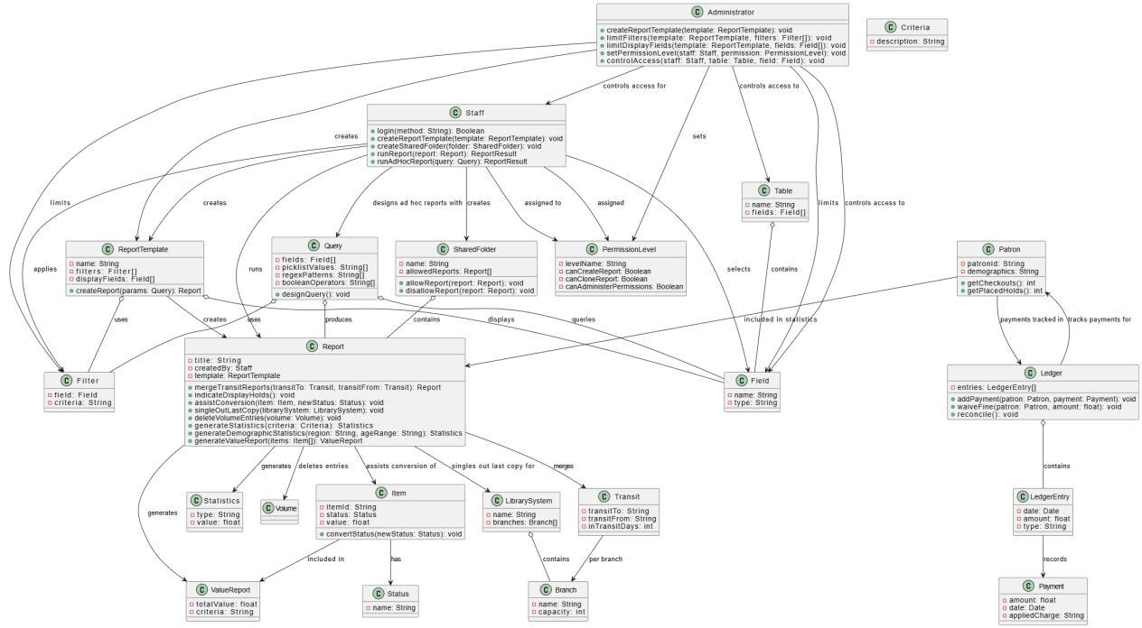

Class Diagram (VeriGen)

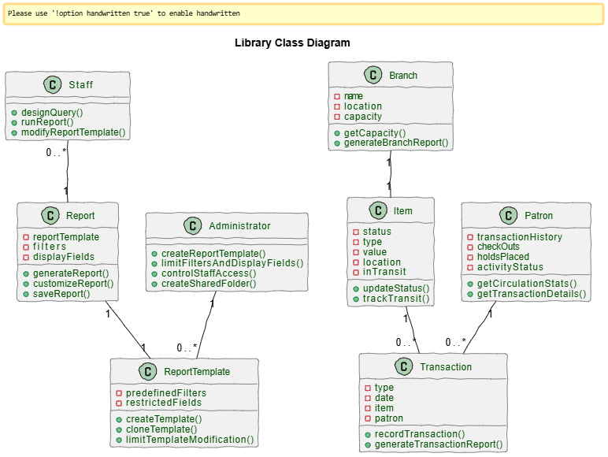

Sequence Diagram (VeriGen)
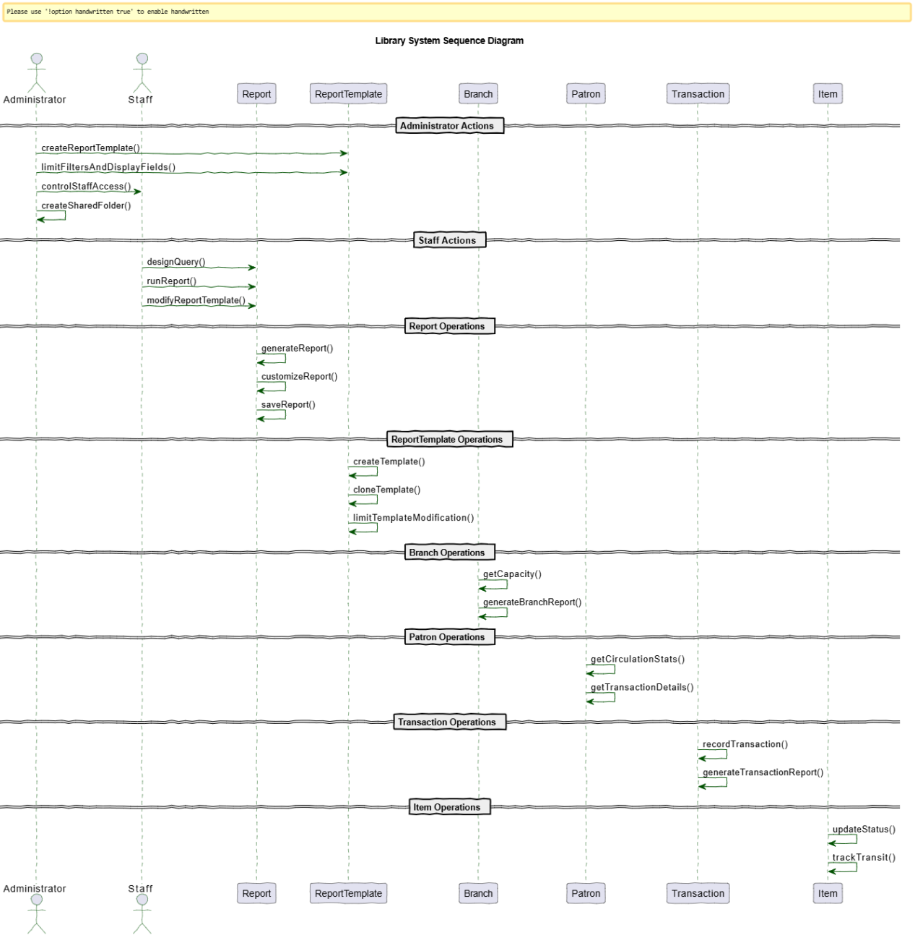

Sequence Diagram (GPT)

